INTERN REPORT

**Submitted By**

**Saurav Kumar**

**IVth Year B.TECH (16BCE075)**

**Jamia Millia Islamia, New Delhi**

**Under the Guidance of**

**Prof. K Sudhakar Reddy**

**Department of Civil Engineering,**

**Indian Institute of Technology**

**Kharagpur**

**Duration**

**ONE & A HALF MONTH (1ST OF JUNE TO 15TH OF JULY)**

**DEPARTMENT OF CIVIL ENGINEERING**

**INDIAN INSTITUTE OF TECHNOLOGY, KHARAGPUR**

**KHARAGPUR - 721302, INDIA**



**CERTIFICATE**

This is to certify that the project report entitled “**Intern Report**”, submitted by Saurav Kumar to Indian Institute of Technology, kharagpur as a part of internship program in Civil Engineering is a record of bonafide work carried out by them under my supervision and guidance during June-July 2019

Date: 15-07-2019 Prof K Sudhakar Reddy

Place: Kharagpur Department Of Civil Engineering

IIT Kharagpur, India

**ACKNOWLEDGEMENT**

I would like to express my special thanks of gratitude to **Dr. K Sudhakar Reddy**, Professor, Department of Civil Engineering Indian Institute Of Technology Kharagpur for his guidance and support throughout my internship. I also take this opportunity to extend my sincere thanks towards Research Scholar **Ms.** **N S L Aparna** for their constant support and motivation during the stay at kharagpur.

I also extend my thanks to other Research Scholar Sri Ramya Mullapudi, Sridhar Reddy Kasu, Priyadarshani shah choudhary, Gurunath Guduru, Baditha Anil Kumar.

I also like to thank Ashish Kumar,Assistant professor,Department of Civil Engineering,MIT Muzaffarpur for his Parent Support.

I would like to thank my friends who helped me a lot im this project within limited time of frame

**TABLE OF CONTENTS**

1. CHAPTER 1: INTRODUCTION
   1. Objective Of Mix Design……………………………………………………6
      1. Asphal Binder Behaviour………………………………………………..6
      2. Mineral Aggregates Behaviour………………………………………….6
   2. Desired Properties Considered For Mix Design……………………………..7
   3. Volumetric Characteristics Of Asphalt mixtures…………………………….8
2. CHAPTER 2: MARSHALL MIX DESIGN……………………………9
   1. Introduction…………………………………………………………………..9
   2. Preparation Of Test Specimen………………………………………………..9
   3. Mix Design Of Bc-2 Using VG-10 Binder…………………………………...9
      1. Mixing And Compaction Temperature…………………………………..10
      2. Determination Of Maximum Specific Gravity…………………………...11
      3. Calculation Of Gmm At Other Binder Content……………………………11
      4. Determination Of Bulk Specific Gravity…………………………………11
      5. Percent Air Voids In Compacted Structure………………………………12
      6. Calculation Of Voids In Mineral Aggregate……………………………..13
      7. Calculation Of Voids Filled With Bitumen………………………………14
3. CHAPTER 3: DESIGN OF FLEXIBLE PAVEMENT……………….16
   1. Introduction…………………………………………………………………...16
   2. Pavement design………………………………………………………………17
4. CHAPTER 4: SUBGRADE SOIL STABILISATION………………...20
   1. Background……………………………………………………………………20
   2. Introduction……………………………………………………………………21

5 CHAPTER 5: LEARNING OF PAVEMENT RELATED TESTING...22

EQUIPMENTS

**WEEKLY JOB SUMMARY**

|  |  |
| --- | --- |
| WEEKS | WORK |
| WEEK 1 | Mix design  (Studied and learnt MS 2, Asphalt institute) |
| week 2 | Mix design  (Experiments) |
| WEEK 3 | Design of flexible pavement |
| WEEK 4 | Read literature on subgrade soil stabilization |
| WEEK 5 | Basic experiment on soil and modified soil |
| WEEK 6 | Learnt pavement related testing equipment |

**CHAPTER 1: INTRODUCTION**

* 1. **Objective of mix design**:

The objective of a mix design is to determine the combination of asphalt binder and aggregate that will give long-lasting performance as part of the pavement structure.

**1.1.1 Asphalt Binder Behaviour:**

Asphalt binder is a visco - elastic material as it simultaneously displays both viscous and elastic characteristics. At higher temperatures (e.g., greater than 100°C), asphalt binder acts almost entirely as a viscous fluid, displaying the consistency of a lubricant such as motor oil. At very low temperatures (e.g., below freezing), asphalt binder behaves mostly like an elastic solid, rebounding to its original shape when loaded and unloaded. At the intermediate temperatures found in most pavement systems, asphalt binder has characteristics of both a viscous fluid and an elastic solid. Asphalt is chemically organic and reacts with oxygen from the environment. Oxidation changes the structure and composition of the asphalt molecules. Oxidation causes the asphalt to become more brittle, leading to the term “age hardening.” Oxidation occurs more rapidly at higher temperatures and higher in-place air voids. A considerable amount of hardening occurs during HMA production, when the asphalt binder is heated to facilitate mixing and compaction.

**1.1.2 Mineral Aggregate behavior:** It must provide enough shear strength to resist permanent deformation. Angular, rough textured aggregates provide more resistance than rounded, smooth-textured aggregates.

**1.2 Desired properties considered for mix design:**

1. ***Resistance to permanent deformation*** *- stability*: Permanent deformation results from the accumulation of small amounts of unrecoverable strain (small deformations) from repeated loads applied to the pavement. Wheel path rutting is the most common form of permanent deformation.
2. ***Fatigue resistance****:* Fatigue resistance is the pavement’s resistance to repeated bending under wheel loads (traffic). Although fatigue cracking is primarily related to an insufficient pavement thickness, air voids and asphalt binder properties have a significant effect on fatigue resistance. The result of a fatigue failure is fatigue cracking, often called alligator cracking
3. ***Low-temperature cracking****:* Low-temperature cracking can be the result of a single event or repetitive cycles of cold temperatures that result in a fatigue type of failure in the mixture. In general, the solution to this problem is the proper choice of binder. Using highly absorptive aggregates, or aggregates with high dust content, can aggravate low-temperature cracking.
4. ***Moisture resistance—impermeability****:* A major problem is associated with moisture damage, commonly referred to as “stripping.” Stripping involves water or water vapor getting between the asphalt film and the aggregates, thereby breaking the adhesive bond between the aggregate and the asphalt binder film. This will “strip” the asphalt from the aggregate.
5. ***Durability****:* The durability of an asphalt pavement is the ability to resist factors such as aging of the asphalt, disintegration of the aggregate and stripping of the asphalt film from the aggregate.
6. ***Skid Resistance****:* Skid resistance is the ability of an asphalt surface to minimize skidding or slipping of vehicle tires, particularly when the roadway surface is wet.
7. ***Workability****:* Workability describes the ease with which a paving mixture can be placed and compacted. Mixtures with good workability are relatively easy to place and compact; those with poor workability are difficult to place and compact.

**1.3 Volumetric characteristics of asphalt mixtures**

The volumetric analysis focuses on the following five characteristics of the mixture and the influence those characteristics are likely to have on mix behavior:

1. ***Mix density****:* The density of an asphalt mixture is defined as the mass of mix per unit of volume.
2. ***Air Voids****:* An air void content that is too high provides passageways through the mix that allow damaging air and water to enter. An air void content that is too low can lead to rutting, shoving, flushing or bleeding. In general, the design air void level in a laboratory-compacted sample of HMA is 4 percent.
3. ***Voids in the mineral aggregate:*** Voids in the mineral aggregate (VMA) must remain high enough to achieve an adequate asphalt film thickness, which results in a durable asphalt pavement , reducing asphalt content by lowering VMA is actually counterproductive and detrimental to pavement quality.
4. ***Voids filled with asphalt****:* Voids Filled with Asphalt (VFA) is the percentage of inter-granular void space between the aggregate particles (VMA) that contains or is filled with effective binder. VFA is used to ensure proper asphalt film thickness in the mix.
5. ***Asphalt content****:* Two terms in asphalt mix technology are used to express the methods of asphalt content: total asphalt content and effective asphalt content. Total asphalt content is the amount of asphalt that must be added to the mixture to produce the desired mix qualities. Effective0 asphalt content is based on the volume of asphalt not absorbed by the aggregate— it is asphalt that effectively forms a bonding film on the aggregate surfaces. The optimum asphalt content of a mix is highly dependent on aggregate characteristics such as gradation and absorption.

**CHAPTER 2: Marshall Mix Design**

**2.1 Introduction**

The Marshall method of mix design is for dense-graded HMA mixes. It is the predominant mix design method for airport pavements. The original Marshall method is applicable only to hot mix asphalt paving mixtures containing aggregates with maximum sizes of 25 mm or less. A modified Marshall method has been developed for aggregates with maximum sizes up to 38 mm. The two principle features of the Marshall method of mix design are a density-voids analysis and a stability-flow test of the compacted test specimens.

**2.2 Preparation of test specimen**

Following steps are recommended for preparing Marshall test specimens:

1. Number of specimens—At least three specimens for each combination of aggregates and binder content are prepared
2. Preparation of aggregates— aggregates to constant weight are dried at 105°C to 110°C and the aggregates are separated by dry sieving into the desired size fractions
3. Determination of mixing and compaction temperature—the temperature to which the asphalt must be heated to produce viscosities of 170 ± 20 centistokes kinematic(f 0.17 ± 0.02 Pa-s.) and 280 ± 30 centistokes kinematic(0.28 ± 0.03 Pa-s.) shall be established as the mixing temperature and compaction temperatures, respectively.

**2.3 Mix Design of BC-2 using VG-10 binder**

**2.3.1 Mixing and Compaction Temperature**

The purpose of using equiviscious mixing and compaction temperatures in laboratory mix design procedures is to normalize the effect of asphalt binder stiffness on mixture volumetric properties. In an asphalt mix facility, the mixing temperature can best be defined as the temperature at which the aggregate can be sufficiently dried and uniformly coated, not to exceed 350°F (177°C). The compaction temperature for an asphalt mix is usually in the range of 275–310°F (135–155°C) and is based solely on the ability of the compaction equipment to achieve adequate in-place density.

Firstly, mixing and compaction temperatures of VG-10 bitumen are obtained as 1650c &1550c respectively from plot of viscosity vs temperature (using the data of Rotational viscometer) as shown in figure 1.

Figure 1: viscosity vs temperature

Using the equation fitted to the data points in the above graph, mixing and compaction temperatures are obtained as 155 oC and 165 oC.

|  |  |
| --- | --- |
| Seive sizes | Cumulative %Age Passing |
|  |  |
| 19 | 100 |
| 13.2 | 95 |
| 9.5 | 79 |
| 4.75 | 62 |
| 2.36 | 50 |
| 1.18 | 41 |
| 0.6 | 32 |
| 0.3 | 23 |
| 0.15 | 16 |
| 0.075 | 8 |
| Dust | 1 |

Table 1 Gradation Of Aggregate (Binder Content-5%)

Gradation corresponding to NAS (Nominal Aggregate Size) 13.2 is done as shown in table 1. the aggregates and binder are heated to their mixing temperatures (approx. 165oC) separately and then mixed in proportion to its mixing temperature and are poured in a mould of diameter 100mm then compacted using compactor with 75 blows (For Heavy Traffic) on each side at its compaction temperature 155oc and then after samples are extracted from mould using extractor machine further the preliminary test are conducted on the samples like determination of bulk specific gravity (Gmb) ,Maximum specific gravity (Gmm) etc. to find the air voids and optimum binder contents at 4% voids.

**2.3.2 Determination of maximum specific gravity (by pycnometer method):** It includes only voids filled with bitumen and excluding the voids filles with air.

Data and calculation are shown in table 2

|  |  |  |  |
| --- | --- | --- | --- |
| Wt. of Mix | Wt. of bottle + mix + water | Wt. of bottle+Water | Gmm |
| 490.5 | 1122.4 | 1424.8 | 2.608 |
| 489.7 | 1122.4 | 1424.8 | 2.615 |
| 489.2 | 1122.4 | 1424.8 | 2.619 |
| Average Gmm | | | 2.614 |

Table 2: Calculation of max specific gravity (at binder content-5.5%)

**2.3.3 Calculation of Gmm at other binder content:** we calculated effective specific gravity of aggregate (Gse) and then we found Gmm at each binder content which is shown in tabular form:

|  |  |  |  |  |  |  |
| --- | --- | --- | --- | --- | --- | --- |
| Binder content | Ps | Pb | Gmm(5.5) | Gb | Gse | Gmm Avg |
| 5% | 95 | 5 | 2.614 | 1.030 | 2.871 | 2.635 |
| 6% | 94 | 6 | 2.614 | 1.030 | 2.871 | 2.593 |

Table-4: Calculation of Gmm at other binder content

**2.3.4 Determination of bulk specific gravity:**

Bulk specific gravity of mix sample is find using Archimedes Principle. Dry wt. of sample is taken in air (W1),submerged is taken in water bath (W2) and then the sample is kept in water bath for 5-10 mins and then the saturated surface dry wt(W3) is taken

|  |  |  |  |  |  |  |  |  |  |
| --- | --- | --- | --- | --- | --- | --- | --- | --- | --- |
| Binder content | 5.00% | | | 5.50% | | | 6% | | |
| W1 | 1231.5 | 1237.5 | 1228 | 1214.5 | 1231.5 | 1237.5 | 1227 | 1240 | 1236 |
| W2 | 707.5 | 742 | 740 | 735 | 748.5 | 750 | 743.5 | 753 | 750.5 |
| W3 | 1236 | 1238 | 1229 | 1215.5 | 1232.5 | 1238 | 1227.5 | 1242 | 1237.5 |
| Gmb | 2.330 | 2.495 | 2.51 | 2.528 | 2.544 | 2.536 | 2.535 | 2.536 | 2.538 |
| Gmb Avg | 2.506 | | | 2.539 | | | 2.537 | | |

Table-3: Calculation of bulk sp.gravity

**2.3.5 Percent air voids in compacted mixture:**

Using Formula Pa =100 –((100*Gmb)/Gmm)

Pa = air voids in compacted mixture, percentage of total volume, Gmm = maximum specific gravity of paving mixture, Gmb = bulk specific gravity of paving mixture.

Now we can find bitumen content at 4% air voids from a plot of air voids vs bitumen content. From table, we can conclude that minimum & maximum % air voids is 3 and 4 respectively which is coincide with the marshall design criteria given by Asphalt institute And also it is suitable for heavy traffic surface and base.

|  |  |  |  |
| --- | --- | --- | --- |
| Binder content (%) | Gmb | Gmm | Pa |
| 5 | 2.506 | 2.635 | 4.9 |
| 5.5 | 2.539 | 2.614 | 2.9 |
| 6 | 2.537 | 2.593 | 2.2 |
|  |  |  |  |

Table 5:percent air void at different binder content

Graph-2 Air voids vs binder content

Now for calculating VMA we have to find GSb (Bulk sp. gravity of aggregate):

|  |  |  |  |  |  |  |  |  |  |  |  |
| --- | --- | --- | --- | --- | --- | --- | --- | --- | --- | --- | --- |
| Sieve size | 19 | 13.2 | 9.5 | 4.750 | 2.36 | 1.18 | 0.6 | 0.3 | 0.15 | 0.075 | dust |
| sp. gravity | 2.854 | 2.850 | 2.849 | 2.830 | 2.729 | 2.733 | 2.651 | 2.651 | 2.651 | 2.512 | 2.520 |

Table-6: sp.gravity of aggregate

GSb = (P1+P2………………+Pn)/(P1/G1+……………….Pn/Gn);

Where,

P1,P2………………,Pn  are percentage of aggregate by weight

G1,G2,………..Gn  are sp. Gravity of aggregate

So using this formula, we found Gsb=2.757 which remains constant for different binder content.

**2.3.6 Calculation of Voids in Mineral Aggregate (VMA):**

VMA is calculated using the following equation:

VMA = 100-((Gmb*Ps)/Gsb).

Graph of VMA vs Asphalt content is plotted. The voids created by the aggregate structure of a compacted asphalt mixture, expressed as a percentage of the total mix volume. VMA represents the volume of air voids and effective (non absorbed) asphalt binder.

|  |  |  |  |  |
| --- | --- | --- | --- | --- |
| Binder content | Gmb | Gsb | Ps | VMA |
| 5 | 2.506 | 2.757 | 95 | 13.649 |
| 5.5 | 2.539 | 2.757 | 94.5 | 12.972 |
| 6 | 2.537 | 2.757 | 94 | 13.501 |

Table 7: Voids in mineral aggregate

Graph-3 VMA vs binder content

**2.3.7 Calculation of Voids Filled with Asphalt (VFA):** As per mix design criteria of Asphalt institute VFA should be 75% which is shown in table below. At optimum binder content i.e, the VFA is 70%. The percentage of the VMA filled with effective (non absorbed) asphalt binder

|  |  |  |  |
| --- | --- | --- | --- |
| Binder content | Pa | VMA | VFA |
| 5 | 4.896 | 13.649 | 64.129 |
| 5.5 | 2.869 | 12.972 | 77.883 |
| 6 | 2.160 | 13.501 | 84.001 |

Table: 8 Voids filled with asphalt

A plot of VFA vs Asphalt content is plotted as shown below:

Graph:4 VFA vs Asphalt content

**CHAPTER 3: Flexible Pavement Design**

**3.1 Introduction**

Pavement design is done on the basis of multi-elastic theory as per guidelines of IRC-37 2012 which is applicable for traffic more than 2msa

**3.2 Pavement Design**

1. *Problem*

Pavement Design for BC+DBM+WMM+CTSB with Modified Binder and with 80% Reliability

Under this option of Flexible pavement design is done using Cement Treated Sub-base CTSB as Sub Base layer and accordingly pavement layer BC, DBM, WMM and CTSB are considered over sub-grade layer with 8% CBR. Elastic Modulus values and Poisson’s ratios considered while doing the analysis are as per the guidelines given in IRC-37: 2012 and are presented below

• Elastic Modulus of Modified Binder: 1650 Mpa (350C)

• Sub-Grade CBR Considered: 8%

• Elastic Modulus of WMM: 350 Mpa

• Elastic Modulus of Cement Treated Sub-base CTSB: 600 Mpa

• Elastic Modulus of Subgrade: Based on equation in given in IRC depending on CBR of Sub-grade

• Standard Wheel Load : 20KN

• Tyre Pressure : 0.56 Mpa

• Poisson ratio for Asphalt Layers: 0.35

• Poisson Ratio for Granular Layers: 0.35

• Poisson Ratio for CT Sub-base Layers: 0.25

• Poisson Ratio for Subgrade: 0.35

The strains were calculated using program IIT PAVE at the following critical locations:

• Tensile Strain at Bottom of Bituminous Layers

• Vertical Compressive Strain on top of Subgrade

1. *Solution*

Analysis for 10 MSA / 25 MSA: BC+DBM+WMM+CTSB with Modified Binder and 80% Reliability

Now using catalouge provided by IRC-37-2012 for CBR of 8% thickness of respective layers and modulus of elasticity for each layer are noted down as shown in table 9 below:

|  |  |  |  |  |  |
| --- | --- | --- | --- | --- | --- |
| CBR | BC(mm) | DBM(mm) | WMM | CTSB(mm) | SG(mm) |
| 8% | 30 | 50 | 150 | 200 | 500 |
|  | Total Bituminous Thickness=  80 mm | | Aggregate Interlayer Thickness=150 | Total CTSB  Thickness=200 |  |
| Elastic Modulus | 1650MPa | | 350MPa | 600MPa | 66.6MPa |

Table 9

Then using Iit Pave software pavement design can be done easily by giving all the inputs like

Thickness of each layer, modulus elasticity of each layer, poission’s ratio, wheel load = 20000,

tyre pressure=0.56MPa (0.86Mpa in case of CTSB) , no of analysis points , wheel set (dual set)

and click on after filling all input screen is shown in Figure 1.and then click on RUN

command after which output screen is appeared as shown in figure 2.From the output screen

we have to take maximum value for critical tangential strain below the bituminous layer and vertical subgrade strain which is above subgrade.

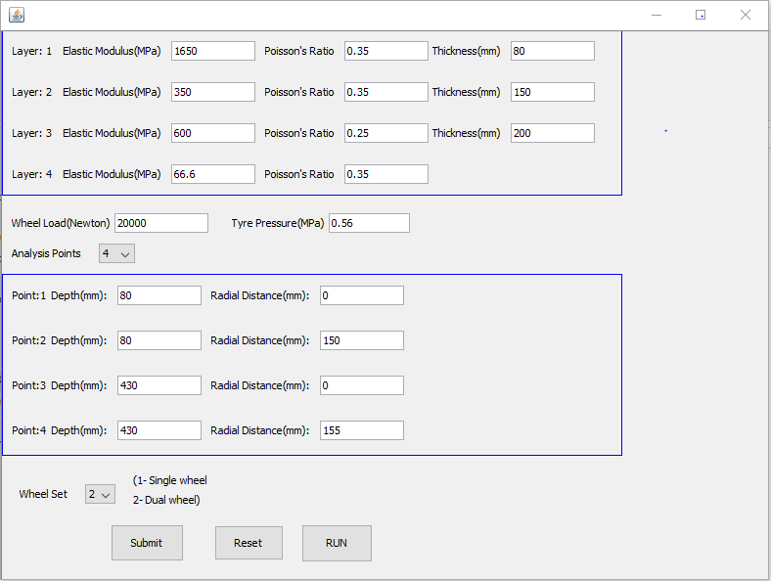

Figure 1: Input Screen

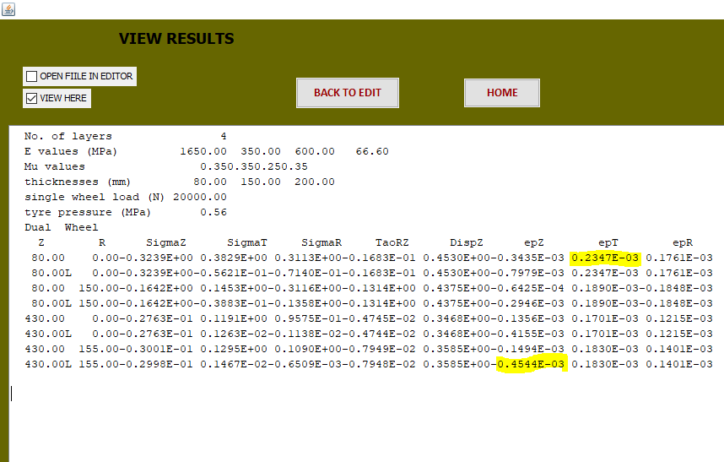

Figure 2: Output Screen

Critical Tangential Strain=0.2347E-03=234.7

Critical Vertical Strain=0.4544E-03=454.4

Using formula of fatigue life for 80% reliability

. Nf = 2.21 * 10-04 x [1/εt]3.89 * [1/MR]0.854

Substituting the value of MR and tensile strain we get fatigue life =51.92msa

Using formula of rutting life for 80% reliability

Nr= 4.1656 x 10-08 [1/εv]4.5337  , putting value of vertical strain we get rutting life=59.41

Minimum life served is=min (Nf,Nr )=51.92msa

Hence our proposed design MSA is 10MSA/25MSA which is satisfied by minimum life served

Thus, it is safe design.

**CHAPTER 4: Subgrade Soil Stabilization**

**4.1 BACKGROUND:**

India is geologically active and a wide variety of soil types occur across the Country. A thorough understanding of these subgrade soils in any pavement project area is essential to appropriately engineer the construction, rehabilitation, or widening of a highway facility. Subgrade is defined as “Roadbed portion on which pavement, surfacing, base, subbase, or a layer of any other material is placed.” It is the soil or rock material underlying the pavement structure, and unlike base and wearing course (surfacing) materials whose characteristics are relatively uniform, there is often substantial variability of engineering properties of subgrade soils over the length of a project. Since pavements are engineered to distribute stresses imposed by traffic to the subgrade, the subgrade conditions have a significant influence on the choice and thickness of pavement structure and the way it is designed. Depending on the existing soils and project design, the properties of the subgrade may need to be improved, either mechanically, chemically, or both, to provide a platform for the construction of subsequent layers and to provide adequate support for the pavement over its design life. Stabilization of subgrade materials has a number of benefits. Firstly, it eliminates the need to excavate substandard materials, transport them to a suitable site where they can be disposed of, and then excavate and import more suitable materials. Secondly, it improves the properties of existing materials, thereby providing a good platform for the overlying pavement layers.

**4.2 INTRODUCTION:**

Expansive soils/Black cotton soils are basically Montmorillonitic clays which displays a tendency to swell or heave during the process of wetting and to shrink when dry as evidence by shrinkage cracks. When subjected to seasonal wetting and drying, a road built on an expansive soil subgrade will cause uneveness of pavement surface. In order to prevent such an unsatisfactory performance various methods of stabilisation of subgrade soil are available some of them are discuss below:

1. Mechanical stabilization: Blending mixing fraction so as to produce a mass of maximum possibility density and with plasticity within limits.
2. Lime stabilization: Lime in hydrated form reacts with the clay minerals in the soil to cause (i) immediate reduction in plasticity and increase in CBR because of cationic exchange, flocculation and agglomeration which may be reversible under certain condition. (ii) Long term chemical reaction with the clay minerals to produce cementitious products which binds the soil for increased strength and stability.
3. There are many other methods of soil stabilization are cement stabilization, bitumen stabilization, lime flash stabilization and two stage stabilization.

Many research is going on soil stabilization abroad and across the country, but I performed some simple soil test like free swell index test & plasticity test on expansive soil of FSI(Free swell index) initially of 45 % but after addition of lime to that expansive soil Free swell index decreases. On addition of 5% of lime to soil FSI decreases by 1% and on 10% of decreases to 2%.An important phenomenon reported by many researchers is the ability of lime to change the plasticity of soils. Both the liquid limit and the plastic limit indices, where the plastic limit indicate the plasticity of soil, are influenced by lime, which affects the thickness of the diffuse hydrous double layer surrounding the clay particles. Whereas the liquid limit of clay soils is found to decrease with increased lime content ([Wang et al. 1963](https://ascelibrary.org/doi/full/10.1061/%28ASCE%29MT.1943-5533.0000431); [Bell 1988](https://ascelibrary.org/doi/full/10.1061/%28ASCE%29MT.1943-5533.0000431)), the plastic limit generally shows an increasing trend ([Herrin and Mitchell 1961](https://ascelibrary.org/doi/full/10.1061/%28ASCE%29MT.1943-5533.0000431); [Barker et al. 2006](https://ascelibrary.org/doi/full/10.1061/%28ASCE%29MT.1943-5533.0000431)). A greater amount of clay results in a higher, lime-induced increase in the plastic limit ([Hilt and Davidson 1960](https://ascelibrary.org/doi/full/10.1061/%28ASCE%29MT.1943-5533.0000431)). Correspondingly, the plasticity index, the mathematical difference of the liquid limit and the plastic limit that quantifies the plasticity of soils, is generally found to decrease with lime amendment ([Herrin and Mitchell 1961](https://ascelibrary.org/doi/full/10.1061/%28ASCE%29MT.1943-5533.0000431); [Bell 1988](https://ascelibrary.org/doi/full/10.1061/%28ASCE%29MT.1943-5533.0000431)), making the soil more friable and therefore more workable.

**CHAPTER 5: Learning of pavement related testing equipments:**

1. 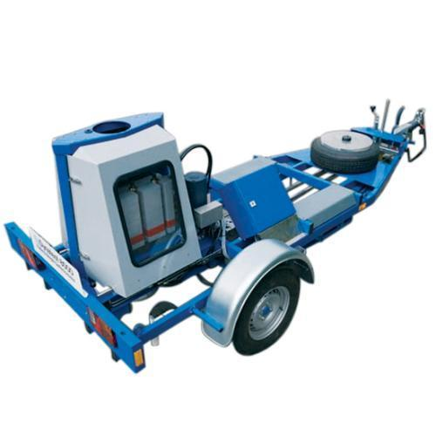**Falling Weight Deflectometer (FWD):** It works on the principle of applying impulse load to the pavement and measuring the shape of the deflection bowl. In general, the FWD consists of an arrangement to raise a specified mass to specified height to let it fall free lyon a loading plate placed on the surface through a spring. FWD pavement evaluation data includes load applied load plate radius surface deflection at different radial distances and this data is used to back calculate the material properties of different Fig. Falling Weight Deflectometer

Layers in flexible pavement.

1. 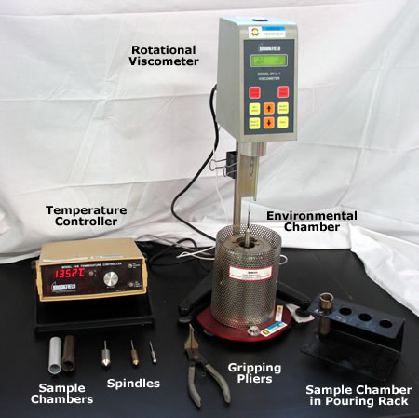**Rotating Viscometer**: The Principle behind this method involves torque required to rotate cylinder is dependent on viscosity of fluid. It is used to determine the viscosity of asphalt binders in the high temperature range of manufacturing and construction. It is mainly used in determining mixing and compaction temperature of bitumen.
2. 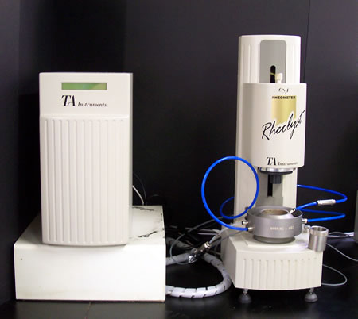**Dynamic Shear Rheometer:** The principle behind this is that the resistance of material to an applied shear rate is measured. The DSR measure a specimen’s complex shear modulus (G*) and phase angle(β*). The complex modulus measures the sample’s total resistance to deformation when repeatedly sheared, while the phase angle is the lag

between the applied shear stress and resulting shear strain. For purely elastic material phase angle is zero degree and for purely viscous material phase angle is 90o.G* and β* are used as predictors of hot mix asphalt rutting and futigue cracking.

1. **UTM(universal testing machine):** This method cover the procedures for preparing and testing laboratory-fabricated or field recovered cores of bituminous mixtures to determine

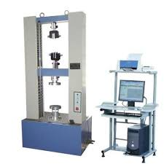 Fig. Universal Testing Machine

resilient modulus values using the repeated-load indirect tension test. The procedures described covers the range of temperature, loads, loading frequencies, and load functions.

**References:**

1. Asphalt Institute Manual Series-2-Mix design Method-7th Edition
2. IRC-37-2018 , Design of Flexible Pavement
3. IRC-SP-72-2015 , Design of Low Volume Roads
4. Institute of Transport studies , California